**Project Design Phase**

**Problem – Solution Fit Template**

|  |  |
| --- | --- |
| Team ID | LTVIP2025TMID29763 |
| Project Name | Airline Management System |
| Maximum Marks | 2 Marks |

**Problem – Solution Fit T:**

The Problem-Solution Fit simply means that you have found a problem with your customer and that the solution you have realized for it actually solves the customer’s problem. It helps entrepreneurs, marketers and corporate innovators identify behavioral patterns and recognize what would work and why

**Purpose:**

✅ **Solve complex airline operations challenges** by aligning Salesforce solutions (like Sales Cloud, Service Cloud, Marketing Cloud) with real-world passenger and staff needs.

✅ **Improve solution adoption and speed of service** by integrating with platforms customers already use — like mobile, email, and chat — through Salesforce Experience Cloud and Marketing Cloud.

✅ **Sharpen communication and support workflows** using Service Cloud and Einstein AI, ensuring the right messages reach the right passengers at the right time.

✅ **Increase customer engagement and satisfaction** by solving frequent issues like delayed updates, disconnected services, and poor support — with automated case routing, live dashboards, and unified customer profiles.

✅ **Gain deep understanding of current customer experiences** and operational gaps through real-time reports and analytics in Salesforce, enabling continuous improvement.

**Template:**

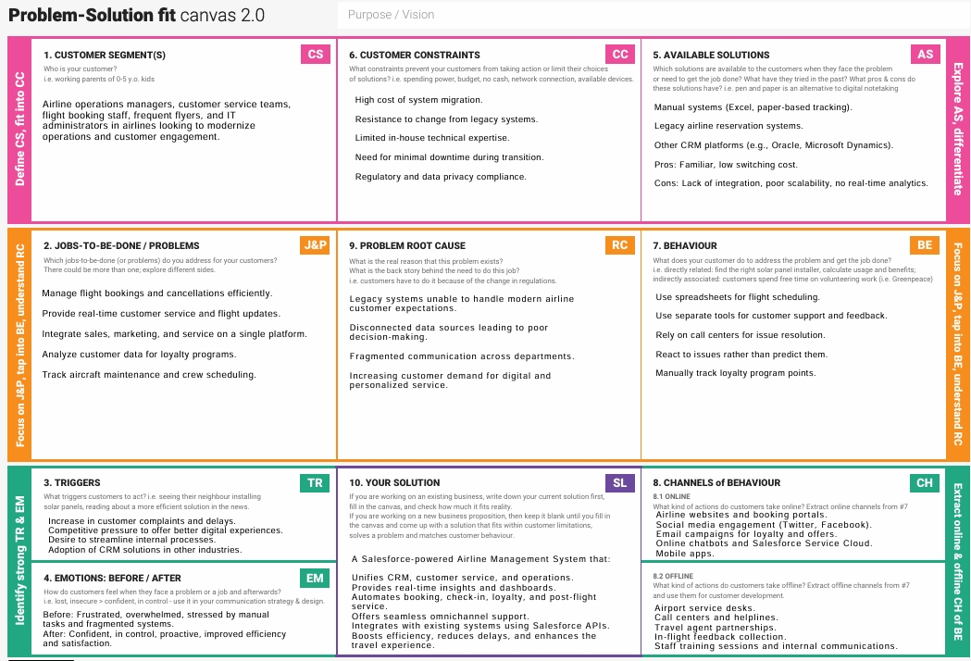

References:

1. <https://www.ideahackers.network/problem-solution-fit-canvas/>
2. <https://medium.com/@epicantus/problem-solution-fit-canvas-aa3dd59cb4fe>